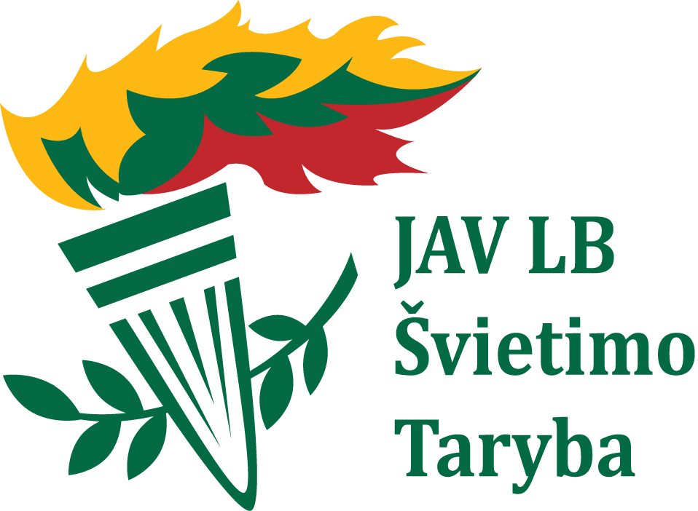 LITHUANIAN LANGUAGE COURSES

CAMP DAINAVA, Manchester, MI
August 4-11, 2019

REGISTRATION FORM

Last Name |  |  |  |  |  |  |  | First Name |  |  |  |  |  |  |  |  |  | Date
Address
City |  |  |  |  |  |  |  |  |  |  | State |  |  |  |  |  |  | Zip
Telephone |  |  |  |  |  | E-mail
(Confirmation of registration and additional camp information will be sent by email, unless otherwise indicated)

 |  | Attending Lithuanian Language Courses for the first time? |  |  |  |  |  |  |  |  |  |  |  |  |  |  | Yes |  |  |  |  | No
 |  | Course Level: |  |  |  |  | Beginner |  |  |  |  |  | Intermediate |  |  |  |  |  | Advanced
 |  | Arriving by: |  |  |  |  | Car |  |  |  |  |  | Train |  |  |  |  |  | Airplane
 |  | Any special dietary restrictions/requirements? ________________________________________________
 | I will be attending the following days:
 | All week |  | Sun. | Mon. | Tues. |  |  |  | Wed. |  |  |  |  | Thurs. |  |  |  | Fri. |  |  |  |  | Sat.
Please submit completed registration form along with the $15 per person registration fee by May 31st, 2019.
Balance due at camp.
Course and Camp Fees:  (includes lodging, meals,  and language courses) | by  5/31 | from  6/1 | Daily  rates |  |  | First and Last Name of individuals being registered | Age | T-shirt size | Course and Camp Fee
Adult | $400 | $450 | $100
Spouse or second adult | $350 | $400 | $90
Youth ages 10 - 18 years | $250 | $300 | $80
Youth ages 4 - 9 years | $190 | $250 | $60
Registration fee per individual | $15 |  |  |  |  | Subtotal: Cost of Course and Camp
(Children‘s program not available for youth under 4.) |  |  |  |  |  | Registration fee per individual:  Payable in advance, non-refundable
When indicating Tee shirt size, please indicate if Youth or Adult sizes are needed. Sizes range S-XL, with other sizes subject to availability |  |  |  |  |  | Voluntary donation to support projects of the Lithuanian Educational Council
 |  |  |  |  |  | Total
Please make checks payable to:  Lithuanian Educational Council of the USA and mail to: |  |  |  |  |  | Deposit (must be at least registration fee)
Kristina Petraitiene  1425 Carleton Ave. Naperville, IL 60565  kpetraitiene@svietimotaryba.org – 630-290-4490 |  |  |  |  |  | Remainder to be brought in to camp  (cash or check)

If you have questions, please contact Ausrele Sakalas, program directress, at ausreles@comcast.net (630-243-6302) and Audrone Elvikiene at aelvikis@svietimotaryba.org (312-969-5762)

Ačiū!

Lithuanian Language Courses are conducted in conjunction with Lithuanian Heritage School Teacher Professional Development Seminars
sponsored by the Lithuanian Educational Council of the USA

